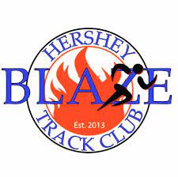
2024 USATF Mid-Atlantic Association Junior Olympic Track & Field Championships
Hershey Blaze Track Club
Meet Information Sheet
June 8-9 Start Time: 8:00am
Widener University |Chester, PA

Event and Check-in Information
Packet pickup: 6:45 a.m.-8 a.m.
Officials Meeting: 7:00 a.m. at the finish line.
Coaches and Volunteers Meeting: 7:15 a.m. at the finish line.
Implement weigh-in: 7:00 a.m.-9:00 a.m.
Warm-ups: The track will be open for warm-ups until 7:50 a.m. After that, athletes must warm up outside the track. A call will be made to allow hurdlers to warm-up over hurdles prior to their races.

Please plan to arrive by no later than 8:15am. The track will be open for warmups only until 7:50am as the Decathlon and other Multievents will start early. The event times schedule are estimates. The meet will be on a rolling schedule. Athletes should be on site and check in 45 mins to an hour prior to their event. It is recommended that athletes be on site at least 2 hours before their event time. Please do not be late.
There will be a team tent area located in the stadium area (map below). Families are encouraged to contribute snacks, fruit, drinks, etc. to share with the team.
Athletes must check in at the designated areas when the first call is made. No athletes will be permitted to check in after an event is closed. NO EXCEPTIONS.
The check-in area for running events will be in the middle of the infield. Field event athletes are to check in directly at the venue.
If an athlete is competing in another event, a coach or parent may check in that athlete. The athlete must report before the event closes.
All athletes must remain in the check-in area after they have checked in.
Spectators: Admission to the stadium by Athletic.net Cash App costs $7 per day or $10 for both days (Athletic.net fees apply) HERE
At the gate, the cost is $10 for one day and $15 for two days. Children under five (5) admitted free.
Spikes: If wearing spikes, it is recommended that 1/4-inch spikes be used.
Timing Services: Fully automatic timing, live track and field results, and meet results will be provided.
BIB NUMBERS
Competitors must wear their assigned bib numbers on the front of their jersey during competition. If an athlete loses a bib number, a replacement can be purchased for $5. Bib numbers will be distributed to coaches and unattached athletes in their registration packets
Parents and coaches are not permitted in the check- in area unless they are checking in an athlete who is competing in another event.
Each athlete’s coach/parent is responsible for making sure the athletes check in to only the events they have entered. Athletes who go over event limits or compete in events they have not been entered in will be disqualified.
Athletes or teams may be disqualified from an event if they fail to adhere to the check-in rules.
Meet Schedule
See meet schedule here https://www.hersheyblazetc.org/2024-outdoor-meet-registration1.html

IMPLEMENTS
Meet Management will provide implements if any.

RESULTS, MEDALS & EVENT PHOTOS
Results will be posted at www.usatf.org on the Junior Olympic page, Athletic.net and at www.mausatf.com
Live results will be in the following link: https://www.athletic.net/TrackAndField/meet/537116/info
Awards will be available for pickup 30 minutes after results are posted. Please make sure your results are correct before leaving the championships. Awards will be picked up at the end of the meet by the Head Coaches only.
Directions:
Address to the stadium: Leslie Quick Stadium 1 University Pl, Chester, PA 19013

We will plan to set up Blaze tents in the area across from the Steeple Chase “pool” and pole vault area
If we are not able to be there, then we will be in the stands to the far left
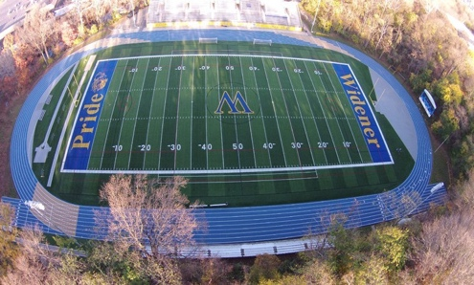
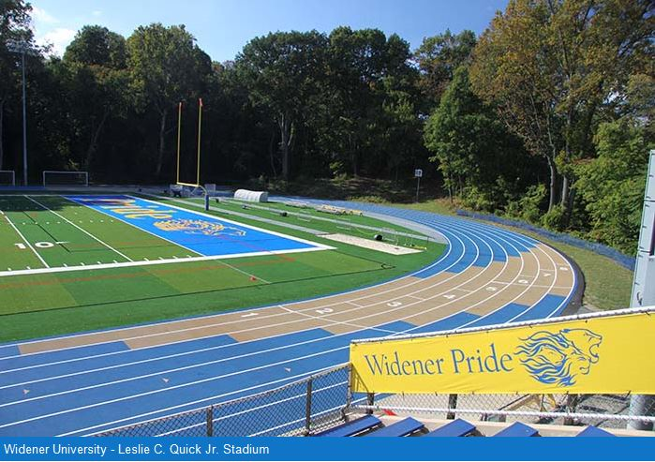
Coaching Contacts
Coach Paynter- (717)222-9626
Jennifer Paynter- (717)222-9687

